**PROJECT TITLE: ENVIRONMENTAL MONITORING**

**PHASE-2 INNOVATION**

**SENSORS**

Environmental sensors measure the environmental conditions of the data center such as the temperature and humidity. Real-time data from environmental sensors is collected, monitored, and reported on by Data Center Infrastructure Management (DCIM) Software  to help data center managers see trends, get alerts, save energy, and increase uptime.

**TEMPERATURE SENSOR**

By monitoring the temperature in your environment, you can identify the formation of hotspots that can damage equipment and cause downtime or know if you are overcooling the data center and overspending on cooling.  The recommended temperature range at the intake is between 18°-27°C / 65°-80°F and the exhaust temperature should be no less than 20°C / 35°F compared to the intake.

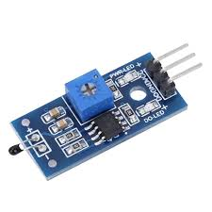

AIRFLOW SENSOR

Proper airflow in a data center will help avoid hot spots and maintain a stable ambient temperature, but cabling and other obstructions can build up over time and disrupt airflow. Monitor airflow to ensure cold air is efficiently cooling the environment or to understand if you need to make adjustments. The recommended airflow sensor placement is one sensor for each cold air supply and one for each hot air return.

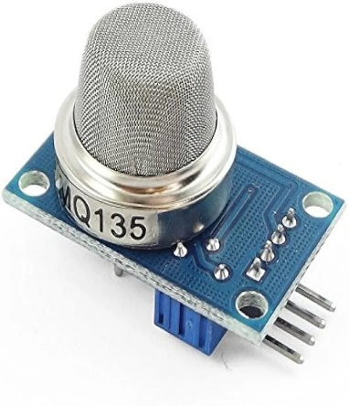

HUMIDITY SENSOR

When the environment is too dry, static electricity can build up. Too humid, and equipment can begin to corrode. Since extreme humidity levels either way can damage equipment and cause downtime and humidity can change depending on outdoor conditions, you must monitor for humidity and maintain a stable environment. ASHRAE recommends that the relative humidity in the data center should be between 40% and 60%. Since humidity does not vary as quickly as temperature, fewer sensors are needed. Typically, one humidity sensor is deployed for every five racks and placed in the front of a rack, but more can be used for extra coverage.

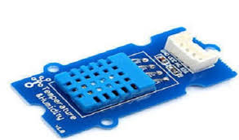

SOUND SENSOR

A sound sensor is defined as a module that detects sound waves through its intensity and converting it to electrical signals. sound sensor consists of an in-built capacitive microphone, peak detector and an amplifier (LM386, LM393, etc.) that's highly sensitive to sound.

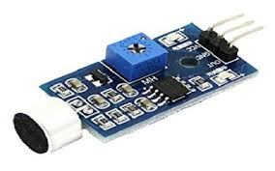

WATER LEAK DETECTION SENSOR

Early detection of water in the data center can give you enough time to prevent a potential disaster. Consider deploying water sensors to avoid downtime caused by undetected air conditioning leakage, condensation, burst pipes, or local failure

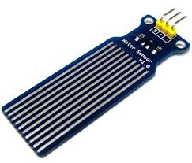

STEPS FOR FLOWCHART

STEP 1: Start

STEP 2: Select Monitoring Parameters

- Identify the specific variables or pollutants to measure (e.g., temperature, humidity, pollutants, pH levels).

STEP 3: Set Monitoring Frequency

- Determine how often data will be collected (e.g., hourly, daily, monthly).

STEP 4: Deploy Monitoring Equipment

- Install sensors, data loggers, or other monitoring devices at chosen locations.

STEP 5: Data Collection

- Continuously or periodically collect data from monitoring equipment.

STEP 6: Data Analysis

- Process and analyze the collected data to identify trends, anomalies, or environmental issues.

STEP 7: Quality Control

- Ensure data accuracy and reliability through calibration and maintenance.

STEP 8: Interpret Results

- Draw conclusions from the data analysis and assess its impact on the environment.

STEP 9: Feedback Loop

- Use monitoring data to adjust monitoring strategies and environmental management practices.

STEP 10: End

FLOW CHART

START

INITIALISE

SENSORS

COLLECT

ALL DATA

ANALYSE

THE DATA

DISPLAY

RESULTS

TAKE ACTION

IF NECESSARY

DISPLAY RESULTS

END

BLOCK DIAGRAM

SENSOR OUTPUT DEVICES

POWER SUPPLY

CONTROL INTERFENCE

DATA STORAGE

ALARAM

LCD DISPLAY

MICROCONTROLLER

SOUND SENSOR

AIR SENSOR

WATER SENSOR

TEMPERATURE SENSOR

HUMIDITY SENSOR

BLOCK DIAGRAM DESCRIPTION:

1.Microcontroller/Main Processing Unit:

This is the brain of the system, collecting data from sensors and process it and managing output actions and displays.

2.Sensor:

Humidity sensor: Connects to the microcontroller to measure humidity.

Temperature sensor: Connects to the microcontroller to measure temperature.

Water sensor: Connect to the microcontroller to measure water.

Air sensor: Connect to the microcontroller to measure air.

Sound sensor: Connect to the microcontroller to measure sound.

3.Communication Interface:

Enables the microcontroller to communicate with external devices or a computer. This can be Wi-Fi, Bluetooth or wired connections like USB or Ethernet.

4.Display:

Shows real time data readings, alerts, or system status

5. Alaram/Notification System:

This can be an audible alarm, LED indicator, or any other signalling device that alerts the user when the desired value goes out of range.

6.POWER SUPPLY:

Provides power to the entire system. This could be batteries, solar panels, or a direct power source.

7.DATA STORAGE:

Where the data can be logged for historical analysis. This could be an SD card, onboard memory, or cloud storage.

8.CONTROL BUTTONS/INTERFACE:

Allows the user to interact with the system, set thresholds, or view historical data.

CIRCUIT DIAGRAM:

